URL: https://adityabirlahospital.com/blogs/emergency-preparedness-monsoon-first-aid-tips/

Meta Title: Emergency Preparedness in Monsoon Season | ABMH

Meta Description: Be ready for monsoon emergencies with simple first aid tips, health precautions, and a complete checklist for safe and healthy rainy days.

Emergency Preparedness in Monsoon: First Aid Tips
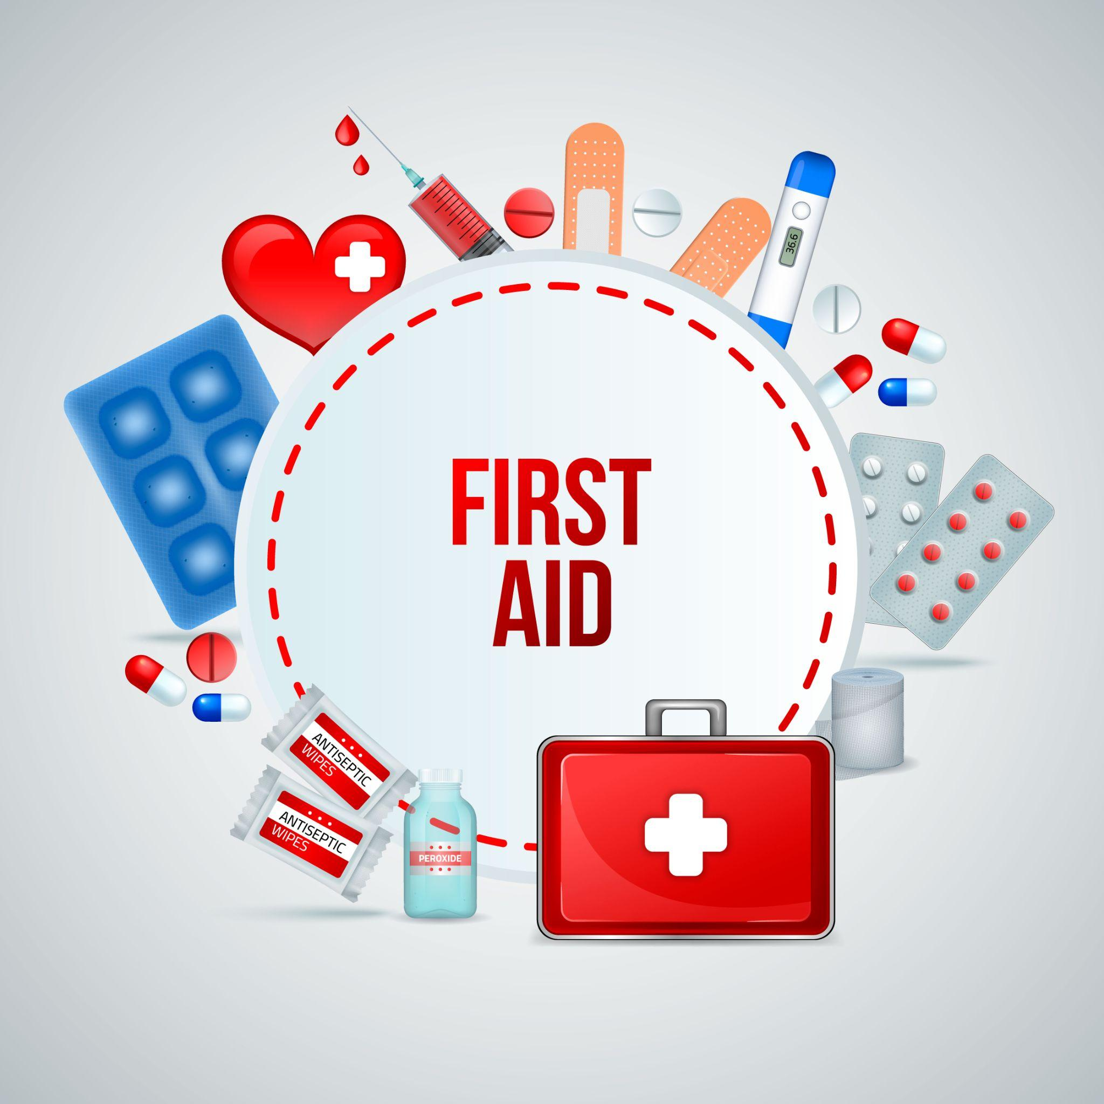

Monsoon is a season of joy—lush greenery, the smell of wet earth, and a welcome break from the heat. But it also brings health challenges: water-borne illnesses, injuries from slips, infections, and unpredictable emergencies. Being prepared with the right first aid knowledge and supplies can make a big difference in keeping your family safe and healthy.
In this blog, we’ll guide you through easy-to-follow first aid tips and monsoon safety practices so you can enjoy the rains without worry.

1. Why Emergency Preparedness is Crucial During Monsoon
The rainy season often leads to:
- - Sudden fevers and infections
- - Increased cases of dengue, malaria, and leptospirosis
- - Road accidents due to slippery surfaces
- - Flooding and waterlogging, causing travel issues
- - Power cuts and blocked access to medical care
That’s why it’s important to be prepared before a problem arises, especially when it comes to first aid and medical emergencies.

2. Build Your Monsoon First Aid Kit
A good first aid kit during the monsoon should cover more than just cuts and bruises. Here's what you need:
Basic Medical Supplies:
- - Adhesive bandages (Band-Aids)
- - Antiseptic solution (Dettol or Betadine)
- - Sterile cotton and gauze
- - Scissors and tweezers
- - Thermometer
- - Pain relievers (Paracetamol, Ibuprofen)
- - Antacids and anti-vomiting tablets
- - Oral Rehydration Salts (ORS)
Emergency Medications:
- - Medicines for fever and cold
- - Antidiarrheal tablets
- - Antihistamines (for allergies)
- - Inhalers (if someone is asthmatic)
- - Prescription medications (keep a week’s stock)
Extra Monsoon Essentials:
- - Mosquito repellents (cream or spray)
- - Hand sanitizer
- - Waterproof pouches (to keep documents and medicines dry)
- - Flashlight with batteries
- - Power bank and charger
Make sure all items are within expiry date and stored in a waterproof box.

3. First Aid for Common Monsoon Illnesses
Fever and Viral Infections:
- - Give paracetamol for fever (not aspirin).
- - Keep the patient hydrated with ORS or soup.
- - Seek medical help if the fever lasts more than 2 days.
Cuts and Wounds:
- - Clean the wound with clean water and antiseptic.
- - Apply antibiotic cream and cover with sterile gauze.
- - Watch for signs of infection like redness, swelling, or pus.
Diarrhea or Vomiting:
- - Use ORS to prevent dehydration.
- - Avoid spicy or oily foods.
- - Give over-the-counter antiemetics or antidiarrheals (as advised by a doctor).
Fungal Infections:
- - Keep the affected area dry.
- - Apply antifungal creams or powders.
- - Avoid tight or wet clothing for long hours.

4. Prevent Mosquito-Borne Diseases
Stagnant water is a breeding ground for mosquitoes—leading to dengue, malaria, and chikungunya.
Prevention Tips:
- - Use mosquito nets and repellents at home.
- - Do not let water collect in buckets, pots, or plant trays.
- - Wear full-sleeved clothes when outdoors.
If someone has a sudden high fever, joint pain, or rashes, consult a doctor immediately.

5. Emergency Travel Safety During Rains
- - Avoid driving through flooded areas.
- - Wear non-slip shoes or sandals.
- - Always carry your first aid kit and basic supplies while traveling.
- - Check weather forecasts before stepping out.
If roads are blocked or flooded, stay indoors and inform someone of your location.

6. Prepare for Power Cuts and Water Shortages
Rainy season often brings disruptions in utilities.
Be Ready With:
- - Battery-operated torch and emergency lights
- - Clean drinking water storage (at least 2-3 days worth)
- - Dry snacks or ready-to-eat food
- - Charged power bank and backup phone

Save these numbers in your phone and keep a printed copy in your kit too.

7. Boost Immunity During Monsoon
Tips to Stay Healthy:
- - Eat light, home-cooked meals.
- - Include turmeric, garlic, and ginger in your diet.
- - Drink boiled or filtered water only.
- - Avoid outside food—especially cut fruits, juices, or chaats.
- - Get adequate sleep and rest.

8. When to Seek Medical Help Immediately
Call for help if:
- - High fever doesn’t come down in 48 hours
- - Someone faints or has a seizure
- - There’s a deep wound or severe bleeding
- - Breathing difficulty or chest pain occurs
- - Vomiting and diarrhea don’t stop despite medication

9. Final Monsoon Safety Checklist ✅
- - [ ] First aid kit is stocked and waterproof
- - [ ] Emergency contacts are saved
- - [ ] Clean water is available
- - [ ] Mosquito protection is in place
- - [ ] Flashlight and power bank are charged
- - [ ] Food and medicine stocks are ready

Conclusion: Be Safe, Not Sorry
Monsoon is beautiful—but only if you're prepared for its unexpected challenges. With a basic first aid kit, emergency supplies, and a little planning, you can enjoy the rains without worrying about what could go wrong.
Remember: it's always better to be safe than sorry. Stay informed, stay alert, and take care of yourself and your loved ones.
Stay healthy, stay prepared—and enjoy the magic of monsoon responsibly!

